Linear Regression

Linear regression is a way to find a straight line that represents the general trend in a set of data points. It helps us understand how one variable changes as another variable changes. The goal is to find the line that best fits the data points and predicts future values as accurately as possible.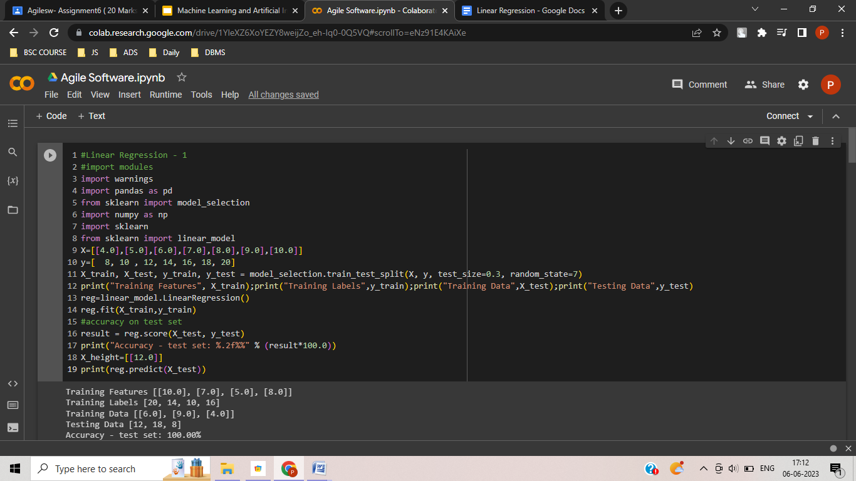

If you look at this code above and refer to line **9 and 10.**

**X** represents a feature or input variable, which is a sequence of numbers from 4.0 to 10.0.

**Y** represents the output values associated with the input values in X. So, for the first element in X, which is 4.0, the corresponding output value is 8, and so on.

In summary, the code defines a dataset with input values **(X)** and corresponding output values **(Y)**. This dataset can be used to perform linear regression, where the goal is to find a straight line that best fits the data and allows for the prediction of output values for new input values.